**Week 1 Project**

**Exhaustive Analysis of Indian Agriculture Using PowerBI**

1. **Load the Dataset into PowerBI :-**

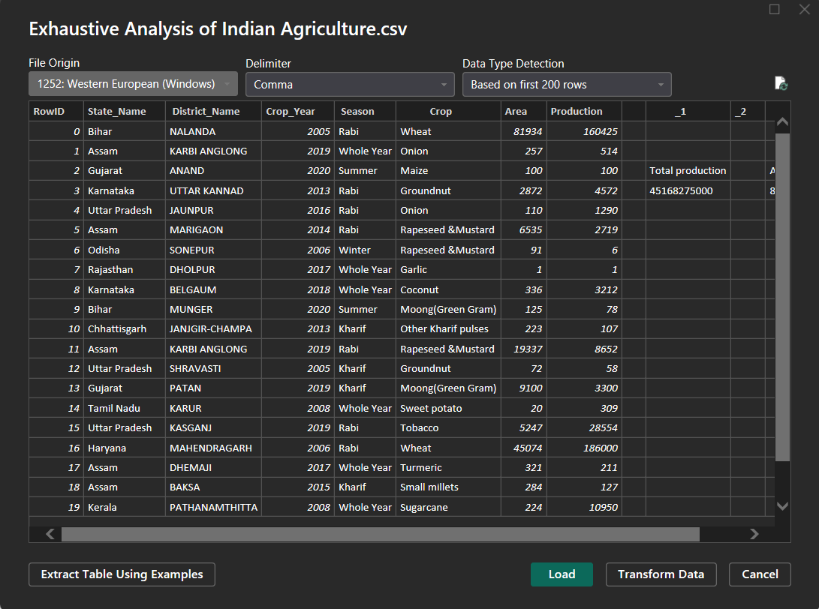

1. **Tables in transform tab :-**

**2.1 Report view:-**

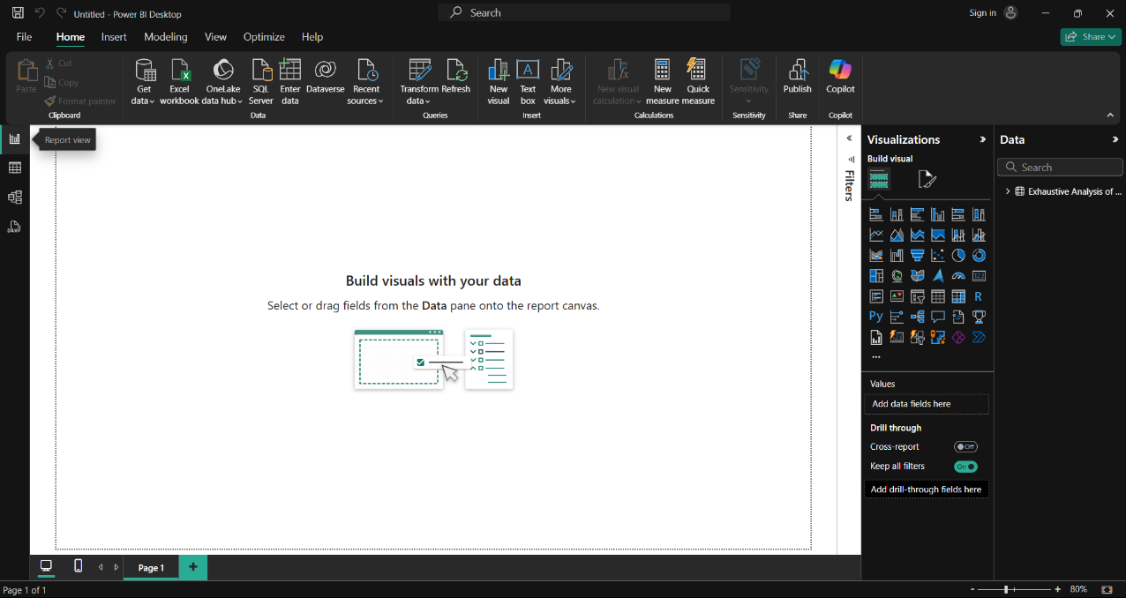

* 1. **Table View :-**

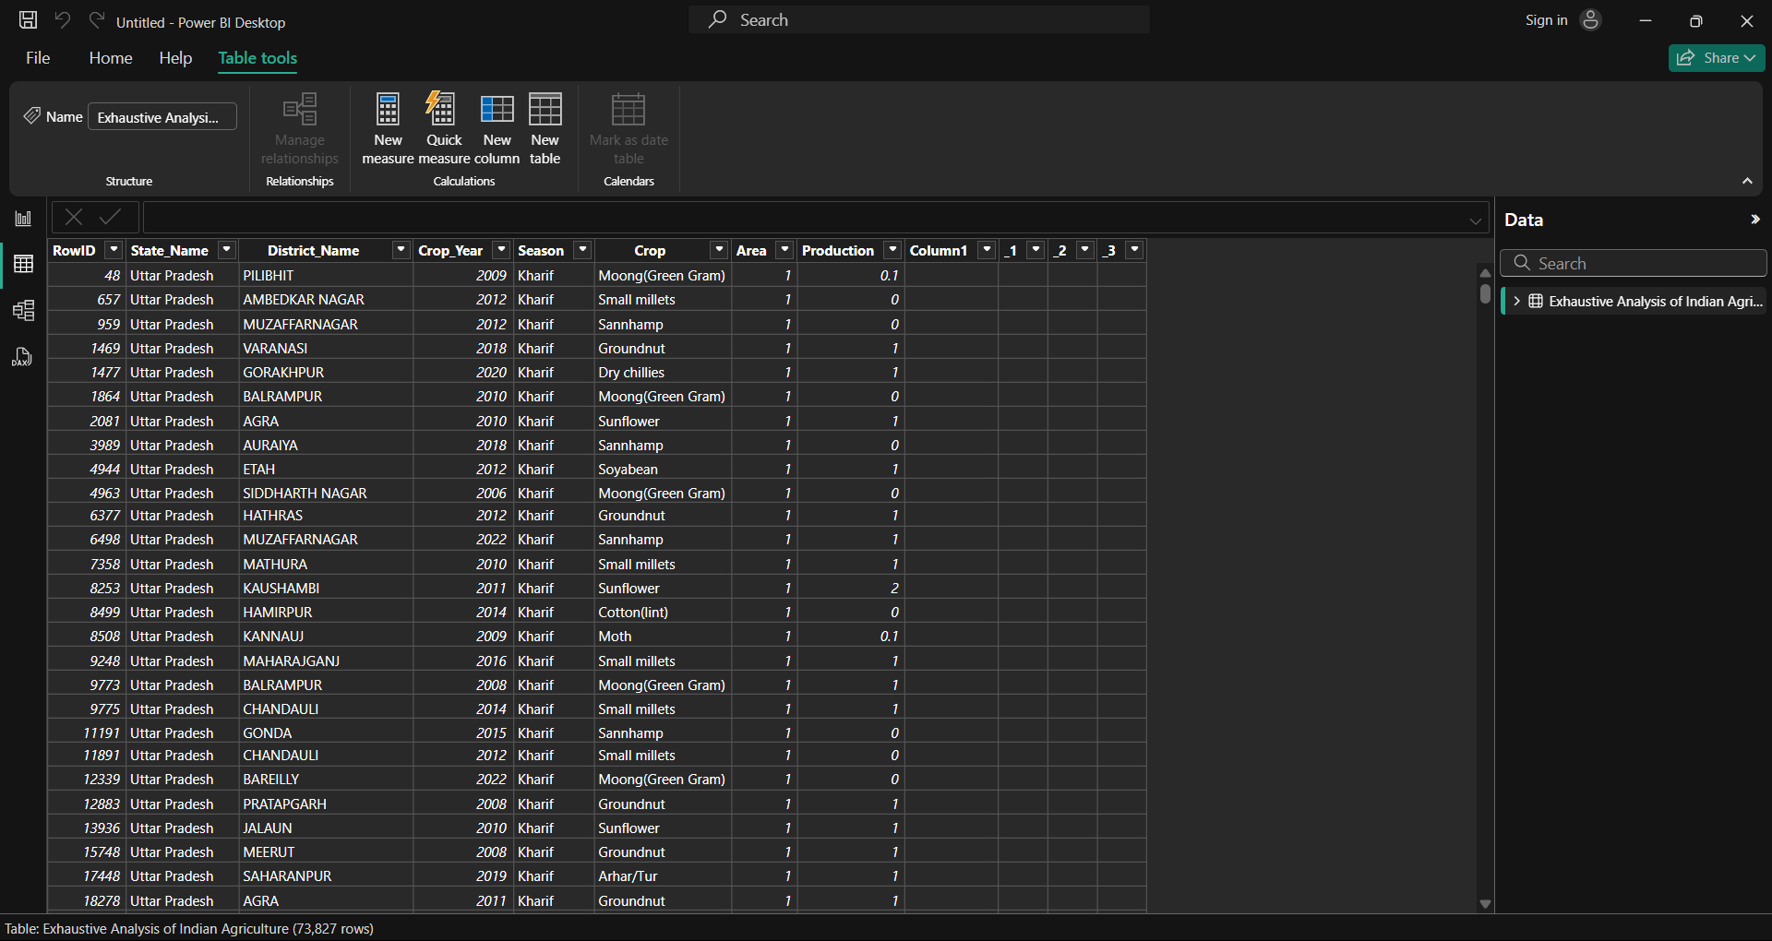

**2.3 Modal View:-**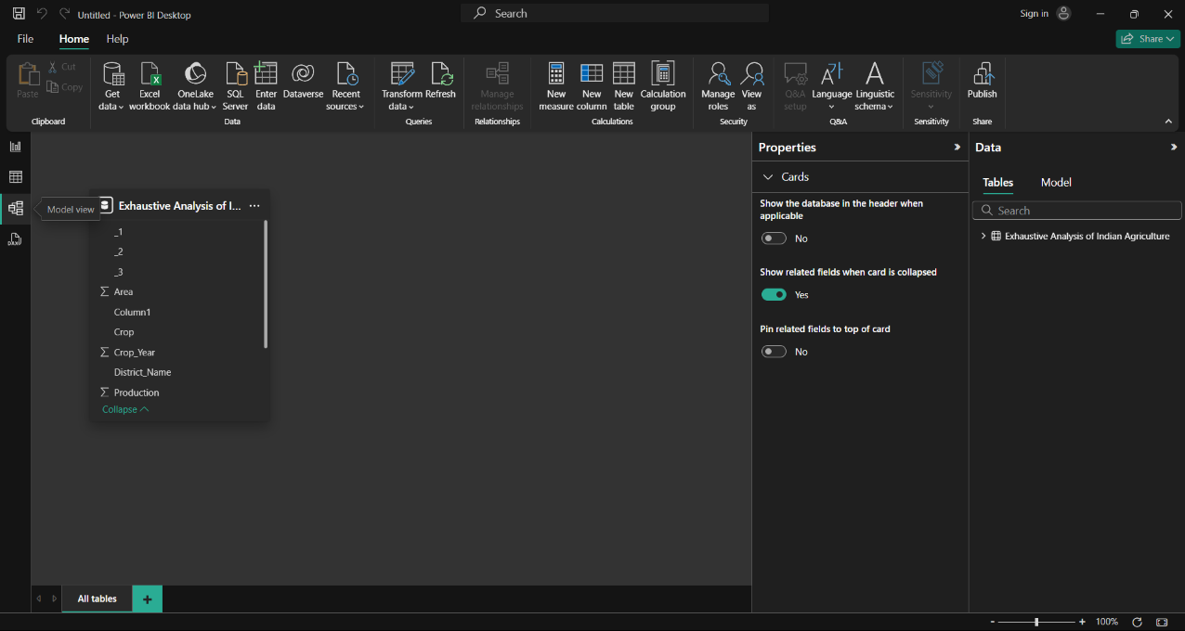

1. **Deletion of Empyt and Unwanted Columns :-  
   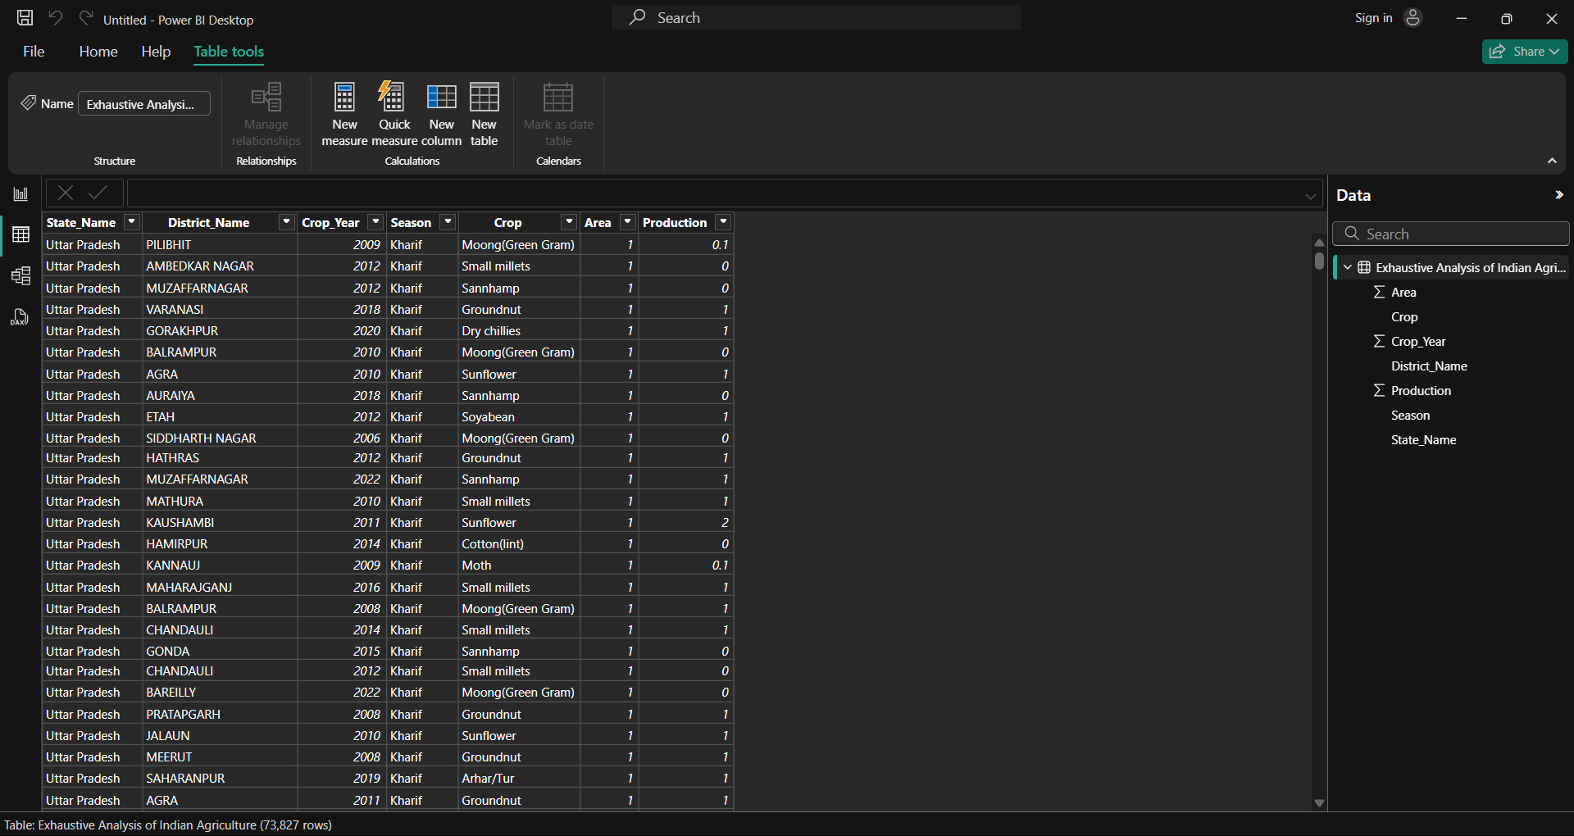**

1. **Columns Quality :-**

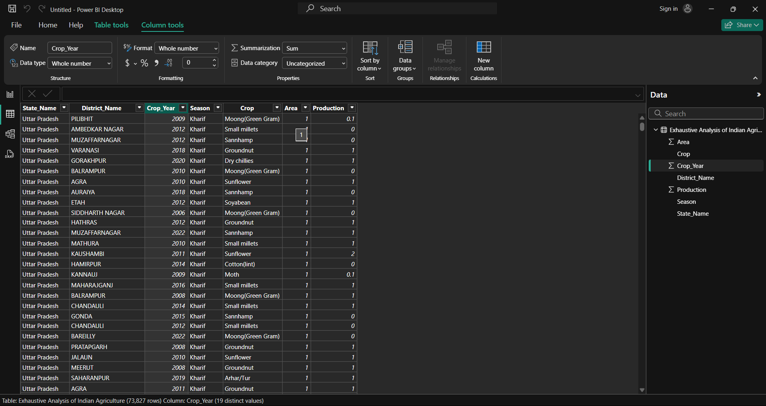

1. **Updated Table at Table View:-**

